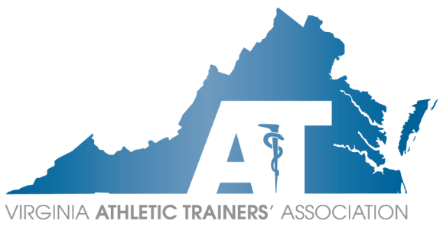
VATA
Executive Council
Annual Meeting Agenda
Sunday, April 07, 2024
7:00 PM – 8:00 PM EST
Mike Kotelnicki MS, LAT, ATC Presiding

Voting EC
Position | Officer | Attendance
President | Mike Kotelnicki
President Elect | Kirk Armstrong
Treasurer | Sara Spencer
Secretary | Tom Campbell
Past President | Danny Carroll
Capital | Annemarie Francis
Central | Devon Serrano
Eastern | Jason Doctor
Shenandoah | Siaura Saville
Tidewater | Corinne Hupp
Western | Anne Bryan
Committees
Committee | Committee Chair | Attendance
Annual Meeting | Sara Pittelkau
ATs Care | Angela White
Constitution & By-Laws | Emily Evans
Council on Practice Advancement | Ashlee Morse
Diversity, Equity, and Inclusion | Brittany Brown
 | Emily Madrak
Research | John Goetschius
Education | Mike Krackow
3rd Party Reimbursement | Brice Snyder
Governmental Affairs | Rose Schmeig
Lobbyist | Becky Bowers-Lanier
Historian | Sherry Summers
Honors & Awards | Jess Kotelnicki
 | Lauren Sander
ICSMC | Kelsey DeShambo
 | Beth Druvenga
Leadership Academy | Heather Murphy
Membership | Katie Grover
Public Relations | Lauryn Hunter
Scholarship | Ellen Hicks
Secondary Schools | Angela White
Student Affairs | Jenn Cuchna
Young Professionals | Mairin Wood
 | Siaura Saville
Guests
KSI Ambassador | Siaura Saville
Task Forces

Officer Reports
President – Mike Kotelnicki
- Passed bill
- Secondary School AT Symposium
- MAATA Annual Meeting
- 50th VATA Anniversary Celebration!
President-Elect – Kirk Armstrong

Treasurer – Sara Spencer

Secretary – Tom Campbell
- Elections timeline
- Website updates
Past President – Danny Carroll

Committee Reports
Annual Meeting – Sara Pittelkau
- Update on financials/budget from January 2024 meeting
ATs Care – Angela White

Committee on Practice Advancement (COPA) – Ashlee Morse

Constitution & By-Laws – Emily Evans

Diversity, Equity, and Inclusion – Kirk Armstrong, Joe Donkor

Education – Michael Krakow

3rd Party Reimbursement – Brice Snyder
- Anthem update
Governmental Affairs – Mike Puglia, Rose Schmeig

Lobbyist – Becky Bowers-Lanier

Historian – Sherry Summers

Honors & Awards – Jess Kotelnicki, Lauren Sander

Intercollegiate Sports Medicine Committee (ICSMC) – Kelsey DeShambo, Beth Druvenga

Leadership Academy – Heather Murphy

Membership – Katie Grover

Public Relations – Lauryn Hunter

Research – John Goetschius

Scholarship – Ellen Hicks
- Status of upcoming scholarships
Secondary Schools – Angela White
- Secondary School AT Symposium
Student Affairs – Jenn Cuchna
- Successfully finished MSAT/MAT Program Instagram Takeovers
- New student liaisons welcomed
  - 8/9 programs
Young Professionals – Mairin Wood

Region Reports
Capital Region – Annemarie Francis

Central Region – Devon Serrano

Eastern Region – Jason Doctor

Shenandoah Region – Siaura Saville

Tidewater Region – Corinne Hupp
- VATA sponsoring CHKD/EVMS Sports Medicine Update
  - June 13th
Western Region – Anne Bryan

Task Forces

Announcements

Guests

Adjournment –

Next Meeting:

