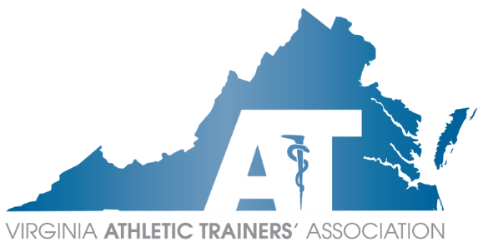
VATA
Executive Council
Conference Call Agenda
Sunday, June 4, 2023
7:00 PM – 8:00 PM EST
Danny Carroll MEd, LAT, ATC Presiding

Voting EC
Position | Officer | Attendance
President | Danny Carroll
President Elect | Mike Kotelnicki
Treasurer | Sara Spencer
Secretary | Tom Campbell
Past President | Chris Jones
Capital | Annemarie Francis
Central | Devon Serrano
Eastern | Jason Doctor
Shenandoah | Paul Peterson
Tidewater | Corinne Hupp
Western | Anne Bryan
Committees
Committee | Committee Chair | Attendance
Annual Meeting | Sara Pittelkau
ATs Care | Angela White
Constitution & By-Laws | Emily Evans
Council on Practice Advancement | Ashlee Morse
Diversity, Equity, and Inclusion | Joe Donkor
 | Kirk Armstrong
Research | John Goetschius
Education | Mike Krackow
3rd Party Reimbursement | Brice Snyder
Governmental Affairs | Rose Schmeig
Lobbyist | Becky Bowers-Lanier
Historian | Sherry Summers
Honors & Awards | Maegan Daniels
ICSMC | Emily Brode
 | Kelsey DeShambo
 | Beth Druvenga
Leadership Academy | Josh Williamson
 | Heather Murphy
Membership | Katie Grover
Public Relations | Lauryn Hunter
Scholarship | Ellen Hicks
Secondary Schools | Angela White
Student Affairs | Jenn Cuchna
Young Professionals | Mairin Wood
 | Siaura Saville
Guests
KSI Ambassador | Siaura Saville
Task Forces

Officer Reports
President – Danny Carroll
- MAATA Annual Meeting Recap
- MAATA Meeting at NATA June 23 5:55PM
- NATA Foundation Ambassador
- Discussion on Code of Ethics
  - Does the VATA need something in place for state-only members?
- Discussion on voting rights
  - Members who are license-eligible, either due to being inactive or awaiting licensure, currently do not have voting rights
President-Elect – Mike Kotelnicki

Treasurer – Sara Spencer
- Budget vote
Secretary – Tom Campbell
- Election results
Past President – Chris Jones

Committee Reports
Annual Meeting – Sara Pittelkau

ATs Care – Angela White

Committee on Practice Advancement (COPA) – Ashlee Morse

Constitution & By-Laws – Emily Evans

Diversity, Equity, and Inclusion – Kirk Armstrong, Joe Donkor

Education – Michael Krakow

3rd Party Reimbursement – Brice Snyder
- Pilot update
Governmental Affairs – Rose Schmeig

Lobbyist – Becky Bowers-Lanier
- Discussions regarding guidance documents and ATs in the OR
Historian – Sherry Summers

Honors & Awards – Maegan Daniels

Intercollegiate Sports Medicine Committee (ICSMC) – Emily Brode, Kelsey DeShambo, Beth Druvenga

Leadership Academy – Josh Williamson, Heather Murphy

Membership – Katie Grover

Public Relations – Lauryn Hunter

Research – John Goetschius

Scholarship – Ellen Hicks
- Changes to format discussion?
Secondary Schools – Angela White

Student Affairs – Jenn Cuchna

Young Professionals – Mairin Wood

Region Reports
Capital Region – Annemarie Francis

Central Region – Devon Serrano

Eastern Region – Jason Doctor

Shenandoah Region – Paul Peterson

Tidewater Region – Corinne Hupp

Western Region – Anne Bryan

Task Forces

Guests

New/Unscheduled Business

Next Meeting: Sunday, July 2nd at 7:00pm

